**COMSATS University Islamabad (CUI)**

**Project Proposal**

**for**

**Templater**

Version 1.0

***By***

**Noor-e-Hira CIIT/FA19-BCS-063/ISB**

**Rana Talha Hassan Khan CIIT/FA19-BCS-069/ISB**

***Supervisor*Ma’am Saira Beg**

***Bachelor of Science in Computer Science (2019-2023)***

**Table of Contents**

Abstract 2

1. Introduction 2

2. Problem Statement 2

3. Problem Solution/Objectives of the Proposed System 2

3.1 Objectives 2

4. Related System Analysis/Literature Review 2

5. Vision Statement 3

6. Scope 3

7. Modules 4

7.1 Module 1: Profile Management 4

7.2 Module 2: Html Components 5

7.3 Module 3: Styling and Animations 5

7.4 Module 4: Documentation of the Template: 5

7.5 Module 5: Trending Templates 5

7.6 Module 6: Recommendation System 6

7.7 Module 7: Fetch and Recreate 6

7.8 Module 8: Learn to Code 6

7.9 Module 9: Feedback and Ratings 6

7.10 Module 10: Trials & Payment 6

8. System Limitations/Constraints 6

9. Data Gathering Approach 7

10. Tools and Technologies 7

11. Project Stakeholders and Roles 7

12. Module based Work Division 7

13. WBS and Gantt Chart 8

14. Mockups 8

15. References 11

16. Plagiarism Report 11

**Project Category:**

□ **B-**Web Application/Web Application based Information System

# Abstract

In a world where everyone is trying to save time and trying to find shortcuts to achieve their goal while saving time and utilizing it in other beneficial activities, it’s the same for a web developer. Every developer needs to create a basic template from scratch to start the significant website working like, where user uses JavaScript, connect database or creates fully functional website.

In the current state, the developer needs to develop the website from the very beginning; mostly, all websites have the same basic working, every developer will repeat the same procedure to create a basic template with HTML components and CSS classes, to resolve this hectic work for the developer, our website will provide code and documentation and with the functionality of fetching and recreating other user’s template. To improve the user experience while using our system, we have included functionalities, one is the reviewing system where the user’s reviews will impact future decisions making and the updates on our website if required.

For a basic website template, HTML and CSS are used; our website will let the user create a fascinating template by molding this scripting and styling languages according to their preferences.

Users will mold HTML and CSS by selecting different sections and by styling them with other classes finally for a classic touch to the template, we also provided the user with the functionality of adding animations to their customized template. Few websites offer to resolve this hectic task but provide limited functionality; our website will fulfill this gap by letting the user select animations, styling, and functionality of fetch and modifying it. And provide documentation for styling and HTML tags to make it easy for junior developers to understand.

# Introduction

Templater is a website that will let the user create a basic template to start their web development. Our website will allow the user to add animations and style the template according to his preference only by selection, avoiding writing the whole code from scratch. The website will let the user break the cycle of repetition. Every developer goes through the same process of creating a basic template with the bonus of allowing the user to add animation and styling templates with provided documentation of used tags and styling classes.

As we know, developers have hectic schedules, so it’s boring and wasting of time to go through the same process again and again, so we are going to develop a website that will break this cycle and will let users create and style the template in an instant by selecting different sections like Navbar, About us, card box, carousel, etc. and then adding styles and animations to the desired sections, provide documentation for the ease of user understanding.

# Problem Statement

A developer at a company or a student at a university needs to develop a website in a short amount of time and an average time to develop a basic structure of a website is usually an hour or two; thus, the developer will waste a significant amount of time on developing that basic structure. Our website will assist the user to save that amount of time and develop the basic structure using our website, and they can focus their time and energy on the task that needs to be done.

For a web developer, it is hectic to always start from the basic styling or always to create a page from a basic syntax. For example, we always need a header, footer, navbar, or article for an essential website, it is tiring for the developer to do the same things repeatedly, and this basic HTML, CSS styling keeps delaying for the developer to create new ideas and start working on them rather than to repeat the same basic procedure.

# Problem Solution/Objectives of the Proposed System

Wouldn’t it be nice to have a solution one click away from you?

We introduced a solution to this problem to save significant time for developers. The developer would have to select the sections they require and add styling and Animation to those sections.

We don’t want developers to waste time on basic procedures. We will provide them with a template where they can select HTML components with proper styling. Users can add animations and provide documentation for styling and HTML tags to make it easy for junior developers to understand. They have to visit our website, special sections, styling, and animations according to their preferences and generate code and documentation. They can start their actual development by copying the code we provide to them.

Trending templates will be displayed for those users who don’t want to customize or create their templates, and will also have access to those trending templates (used mainly by other users).

## Objectives

1. Developers have hectic schedules; the Templater will help them save a significant amount of time.
2. It’s easier for a developer to structure an essential website and instantly start working on developing the actual website.
3. They can customize their templates; either can use trending or available templates.
4. The provided documentation will help the developer to understand the working or can easily explain the syntax of the customized website to any other developer.

# Related System Analysis/Literature Review

There is a website that is already doing what we want to do BUT, on a low level, and they don’t have many details to the template, and they are only giving HTML code, and the details for the template are not too much. We will provide responsive components for the website with a customizable color theme and the paddings and margins and stuff according to the needs of the user.

Table 1 Related System Analysis with the proposed project solution

|  |  |  |
| --- | --- | --- |
| **Application Name** | **Weakness** | **Proposed Project Solution** |
| **quackit.com** | It provides minimal features, has very low reflexivity, and provides a fundamental HTML structure. | We will make it very flexible, and the functionality will be far more than quackit.com. |
|  |  |  |

# Vision Statement

For developers whowant to create a basic website or the basics of any web-based, the Templater **is** an Internet-based and web-enabled application that will let the user create a basic template with HTML tags, styling, and animations to give an appealing state to the template with the addition of documentation that will let user understand the components of his/ger template and works on trial and payment system Unlike, the other related systems we have found (quackit.com) users who use our website (Templater) will not have to create a website from the very beginning or from scratch, which will save them time and they can start their actual development by copying the code we provide to them.

# Scope

The user can surf through the website, view other templates, and utilize the Learn to Code section but when first creating the template, they have to be the first logged in, and if they are not previously registered, they have to create an account first. into the system and then proceed to perform further actions which include creating a template from scratch or recreating a template or just utilizing any other template as it is.

Users, who want to customize their own template select different sections, our website will let the user style individual sections, and let the users add styling and animations according to their preferences. Templater will then generate the code for the customized template and documentation of the used tags. There will be available templates for the users who don’t want to customize their own templates, with the permission of users who create their own templates, let other users consume their creation, and will let our website display their templates to all users. These templates will become public templates (available for all users). Then there come users who don’t want to create the template from scratch for them, Templater will provide the service of fetch and recreate, where the user will fetch available or trending templates and will modify them according to their need.

Users will be provided with trending templates, available templates which are used most frequently by other users, or templates that are famous among other users. This website will also provide the functionality of recommendation where for the very first time the recommendations will be given to them while choosing the template with random options, but after they have created one or two templates or drafts from our website, they will be given proper recommendations about choosing different styles and animation they would like based on their previous decisions.

*Context diagram of the system:*

Figure 1- Context Diagram of the Proposed System

# Modules

## Module 1: Profile Management

In our System, we will have 2 actors one is the admin, and the other is the User.

**7.1.1 Admin**

Admin will be Allowed:

* Register into the System.
* Login in the system.
* Make new Admins.
* Recover Password.

The admin will have full control on the administration side of the Website, like will be allowed to review the feedback and respond to them, and he will be allowed to delete the templates or block any user. As for the registration, the admin will be required to sign in with provided email and password.

**7.1.2 User**

As for the user: will log in if the account is created; otherwise, will sign up to create an account, as well can update their account details, view their saved drafts and used templates, user will be allowed to fetch available templated and can recreate or upgrade them according to their need and can upgrade to the premium account.

## Module 2: Html Components

In this module, we will allow the user to select the navigation bar, header, and footer which the user later wants to style according to his preferences. Users can add an about us, section, carousal section, grid box, and contact us section, in this section he can add text, styling, and animation according to template need, can increase the number of headings according to the need of the template, can also increase the number of carousal and grid boxes according to their preferences.

## Module 3: Styling and Animations

In this module, the user will have the access to style the templates and animation according to his preferences.

**7.3.1 Styling**

In styling, we will provide users with different CSS classes to style their template like background color, font size, padding, etc. The user can add hover effects on buttons and change the font family; we will be providing them with a bunch of Google Fonts.

**7.3.2 Animation**

Animations aren’t a compulsory part of a basic template but for users to create an effective and appealing template this function will let them to create one. This functionality will let the users to add different animations like fading, scrollbar effects, ease-in, etc., to their template for an appealing state.

## Module 4: Documentation of the Template:

In this module, our website will provide documentation of different tags used for the creation of the template, so that later users can understand the components they used for their template creation.

Will provide the documentation for the CSS Elements used, as well the provide them the documentation for the CSS Animations used. We will also let the user know briefly about the section they have used in the building of their template.

## Module 5: Trending Templates

In this module use users can provide their own template for the use of others as well can select trending templates without customizing a new one. The frequently used templates will be selected as trending templates. Like if different users accessed the same template multiple times they will be chosen as trending one, likewise different templates will be moved up and down according to their demand. If users create their customize template, they will be provided with the option to let their own template be used by others.

One of the features included in this is the Graphical representation of the Templates states which will include the number of times that Templates has been used over the period.

## Module 6: Recommendation System

In this module, we will capture user interest for the creation of templates, and then the recommendations system will search for all available templates, and recommend templates that matched their interest (data set ). This will help the user to speed up their surfing on our system and they can focus on the templates that are to their demands.

Recommendations will be provided according to the users’ pattern in creating the Template, information like which kind of component the user is using frequently or in what kind of template the user is showing interest, using this information we will recommend using other available templates which have mostly same components or classes. is liked by user interests.

## Module 7: Fetch and Recreate

In this module, the user will be allowed to fetch the available templates and then recreate them, like if the user fetches the trending template, he can modify that template by adding, removing, and updating the styling and animations, a user does not need to customize the template nor need to use the exact same copy of the template provided by another user, he can just modify the existing template by modifying it according to his preferences.

## Module 8: Learn to Code

This module will be available on the website and the focus of this is from the learning point of view, as the User will have access to the guides and examples of most of the classes and elements of HTML and CSS from which they can understand through our fully detailed examples about them. And then have more knowledge of which component is good to go with the template creation.

## Module 9: Feedback and Ratings

In this module the user can give feedback on trending templates as well can rate custom templates and according to the rating, the templates will become trending or move out from the trending list. Users can also review or give feedback to the website so we can know the cons and pros of the website.

## Module 10: Trials & Payment

In this module, we will be focusing on the payment from the users when the trial period is over, the user will be given a free trial of 3 templates in a month and if he wants to utilize more than this, he will have to apply for the premium account for which he will have to pay. User will be allowed to pay from different platforms.

# System Limitations/Constraints

* Our system will not be able to create a fully Unique and complete website, it will provide a basic structure for the single-page website.
* The website will be made with vanilla HTML CSS, not with any latest technology.

# Data Gathering Approach

For the data gathering, we gathered the data by reviewing different websites and systems like our system and did some Questionnaires with the targeted audience to understand the requirements and expectations of the audience.

# Tools and Technologies

Table 2: Tools and Technologies for Proposed Project

|  |  |  |  |
| --- | --- | --- | --- |
| **Tools**  **And**  **Technologies** | **Tools** | **Version** | **Rationale** |
| VS Code | 1.65 | IDE |
| Figma | - | Design Work |
| **Technology** | **Version** | **Rationale** |
| React JS | 17.02 | Front-end Development |
| Node JS | 16.13.2 | Back-end Development |
| MongoDB | 5.0.5 | Database |
| Express JS | 4.17.3 | Back-end Development |

# Project Stakeholders and Roles

Table 3 Project Stakeholders for the Targeted Project

|  |  |
| --- | --- |
| **Project Sponsor** | COMSATS University Islamabad |
| **Stakeholder** | * Noor-e-Hira and Rana Talha Hassan Khan. * Miss Saira Beg * Final Year Project Committee |

# Module based Work Division

Table 4 Team Member Work Division for Proposed Project

|  |  |  |
| --- | --- | --- |
| **Student Name** | **Student Registration Number** | **Responsibility/ Modules** |
| * Noor-e-Hira | * FA19-BCS-063 | * Module 1 – Module 3 – Module 5 – Module 7 – Module 9 |
| * Rana Talha Hassan Khan | * FA19-BCS-069 | * Module 2 – Module 4 – Module 6 – Module 8 – Module 10 |

# WBS and Gantt Chart

**Figure 2- Gantt Chart**

# Mockups

**Figure 3- Landing Page**

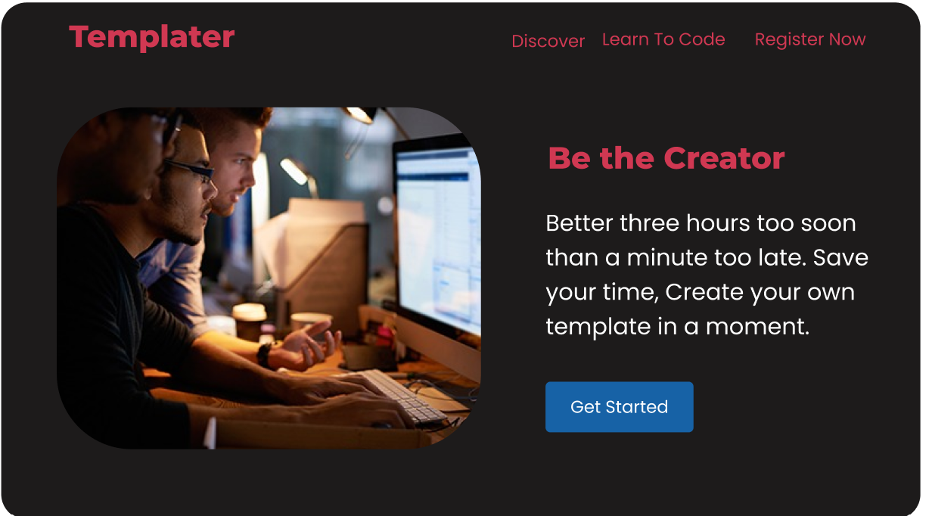

**Figure 4- Dashboard**

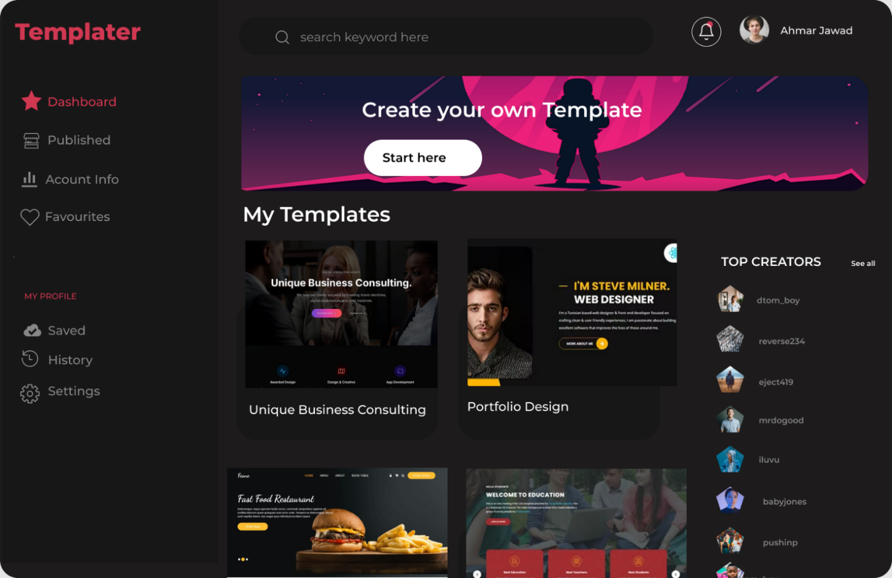

**Figure 5- Templates Page**

**Figure 6- Creating a Custom Template 1**

Figure 7 - Creating a Custom Template 2

# References

HTML code generator. (n.d.). Retrieved April 13, 2022, from <https://www.quackit.com/html/html_generators/html_code_generator.cfm>

*Figma best practices*. Figma. (n.d.). Retrieved April 13, 2022, from

<https://www.figma.com/best-practices/>

# Plagiarism Report

